Trial Match
AgentVerse 2026 · Biotech track · trial-match-ebon.vercel.app · github.com/kaihuang1425/trialmatch
1. The problem
Lung cancer causes around 32,800 deaths a year in the UK, and only 34% of cases in England with a known stage are diagnosed at stage I or II¹. For advanced non-small cell lung cancer (NSCLC), a trial is often one of the best remaining options, yet about one in five adult cancer trials fails to complete, with poor accrual behind 39% of those failures². Matching is hard: the median number of eligibility criteria in thoracic oncology trials rose from 16 to 27 between 1986–95 and 2006–16³, molecular results can take four weeks after biopsy⁴, and trials needing a fresh biopsy see 49.1% screen failure against 26.5%⁵. Black, Asian and Hispanic patients remain under-represented in lung cancer trials⁶.
2. Who it helps
Research nurses pre-screening for phase III lung cancer trials get a ranked shortlist of applicants, with the evidence for every entry rule, instead of checking each rule by hand. Patients with advanced NSCLC see the trials that fit them and why; trial sites gain faster, more representative recruitment. A match needs the patient’s interest and the nurse’s pass.
3. Our data
Trials: Trial Scout searches ClinicalTrials.gov⁷ (API v2) live for recruiting Phase III NSCLC trials with UK sites. The demo and the offline test use 19 synthetic trials (LT-301 to LT-319) whose entry rules are written as code. Patients are synthetic (demo accounts, a SMART on FHIR sandbox patient, made-up clinic letters); missing values stay “not recorded”. An earlier prototype matched 30 de-identified cBioPortal records⁸ against 205 real trials. Licences: ClinicalTrials.gov public domain; cBioPortal open access.
4. How the agent works
Trial Match shortlists recruiting Phase III trials for a person with advanced lung cancer: entry rules decide, and a score only orders what is left. Lung cancer comes first because it has the best-researched data; the approach extends to other diseases. The Records Reader pulls facts from a clinic letter or FHIR record, and the Skeptic drops any fact whose quote is not in the source word for word. The Matcher checks each rule in fixed code: met, not met, or “to check” when a fact is missing. For live trials, a model Pre-check (MedGemma, or Gemini on the hosted demo) reads the full entry rules and names the fact that would settle each unknown. Find and check asks the patient what settles the most trials, checks again, and widens the search if all are ruled out.
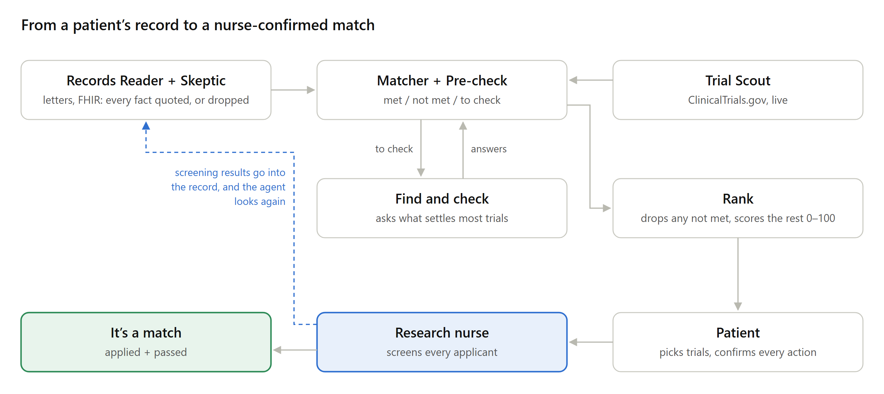
Figure 1. Agent pipeline: a question loop with the patient and a screening loop with the research nurse.
Ranking: a trial with any rule not met is removed, with its reasons. The rest score 0–100: 35% biomarker fit, 20% timing, 20% practicality (travel, visits, randomisation), 15% earlier evidence and 10% certainty. A trial past the patient’s travel limit is hidden, not ruled out: preferences never change eligibility.
Screening loop: the nurse moves each applicant through prescreen, screening and enrolment. Results go into the patient’s record, and if a rule fails, their agent looks for other trials. Chat answers stay marked as the patient’s own until the care team confirms them.
Agents in the chat: a Gemini agent looks up live trials and offers actions (apply, pass, withdraw, apply-for-me, update the record; trial teams can invite people who could fit). Code blocks unsafe actions, such as applying to a trial the patient fails, and nothing happens until the person taps to confirm. For drug questions, a Researcher (Gemini) reads PubMed, FDA labels and ClinicalTrials.gov with public words only and cites a source in every sentence; an Analyst on MedGemma reads that brief against the record. Trials show their drug target in 3D from the Protein Data Bank, and a local mode runs every AI step on MedGemma.
Table 1. Worked example: demo account Mei L. (stage IV adenocarcinoma, EGFR exon 19 deletion, growing on osimertinib, PD-L1 10%, ECOG 1, brain scan not recorded, London, travels up to 25 miles).
Trial | Entry rules | Shown to her | Score
LT-311: HER3-targeted antibody–drug conjugate, London | 8 of 8 met | Strong match | 97
LT-301: new tablet after EGFR treatment, London | 8 met, 1 to check (brain) | Possible match | 97
LT-304: immunotherapy for high PD-L1 | 3 not met (PD-L1, EGFR, earlier treatment) | Ruled out, with reasons | —
Of the 19 demo trials, a registry search lists the 18 for NSCLC (LT-308 is small cell). Trial Match rules out 6, hides 1 past her travel limit and finds 4 with every rule met; the other 7 wait on whether a scan has shown spread to the brain, so her agent asks that first.
5. How we evaluated it
- Matching: on 45,600 synthetic patient–trial pairs (2,400 patients × 19 trials, labels from rules we wrote)⁹, a plain registry search got 93% of its “eligible” matches wrong. Trial Match got none of its “all rules met” matches wrong; counting “to check”, it cut trials to review per patient from 16.7 to 1.6 and still found every real match.
- Tests: automated tests of the Skeptic, the pre-check and the chat agent’s tools and actions pass against a stubbed network, not the live model. An earlier prototype’s parser got 92% (58/63) of fields right on 8 held-out real trials⁹.
6. Limits and safeguards
- Human in the loop: every fact quotes its source; a research nurse screens every applicant; the chat only offers actions, and the tool never enrols anyone.
- Assumptions labelled: the score weights are our own, not validated against real enrolment; results are a demonstration on synthetic data, not real-world performance. Known gaps: a silent yes/no fact reads as “no”, and HER2, NTRK and MET amplification are not modelled. The evaluation caught an unrecorded stage giving “not met”; it now gives “to check”, with a test for every rule.
- Data limits: demo trials and patients are synthetic and written by us; the registry search, Europe PMC and the FHIR test server are real public services.
- Privacy and status: demo data stays in each browser. On the hosted demo, Gemini plays an NHS hospital’s own MedGemma server, labelled “Hospital server (simulated)”, in Google’s cloud, so only synthetic data is used; in local mode, MedGemma keeps the record on the user’s computer. Not a medical device.
References 1. Cancer Research UK, lung cancer statistics. 2. Stensland KD et al., J Natl Cancer Inst 2014;106(9). 3. Garcia S et al., J Thorac Oncol 2017;12(10):1489–95. 4. Mangera Z, Hospital Healthcare Europe. 5. Spiegel ML et al., Cancer 2017;123(24):4800–7. 6. Pang HH et al., J Clin Oncol 2016. 7. ClinicalTrials.gov API v2, US NLM. 8. cBioPortal datahub (TCGA LUAD, LUSC; MSKCC NSCLC 2018). 9. Trial Match team, repository evaluation, 2026.

